Aim: Implement digital signature algorithms such as RSA-based signatures, and verify the integrity and authenticity of digitally signed messages.
Code:
import hashlib
import random
import math

def is_prime(n):
if n < 2:
return False
for i in range(2, int(math.sqrt(n)) + 1):
if n % i == 0:
return False
return True

def generate_prime():
while True:
n = random.randint(100, 300)
if is_prime(n):
return n

def generate_keys():
p = generate_prime()
q = generate_prime()

while p == q:
q = generate_prime()

n = p * q
phi = (p - 1) * (q - 1)

e = 65537

if math.gcd(e, phi) != 1:
e = 3
while math.gcd(e, phi) != 1:
e += 2

d = pow(e, -1, phi)

return (e, n), (d, n)

def sign_message(message, private_key):
d, n = private_key

hash_value = hashlib.sha256(message.encode()).hexdigest()
hash_number = int(hash_value, 16)

hash_number = hash_number % n

signature = pow(hash_number, d, n)

return signature

def verify_signature(message, signature, public_key):
e, n = public_key

hash_value = hashlib.sha256(message.encode()).hexdigest()
hash_number = int(hash_value, 16)

hash_number = hash_number % n

recovered_hash = pow(signature, e, n)

return recovered_hash == hash_number

print("===== RSA DIGITAL SIGNATURE =====")

public_key, private_key = generate_keys()

print("\nPublic Key:", public_key)
print("Private Key:", private_key)

message = input("\nEnter message: ")

signature = sign_message(message, private_key)

print("\nDigital Signature:", signature)

if verify_signature(message, signature, public_key):
print("\nSignature Verification: SUCCESS")
print("Message is authentic and unchanged.")
else:
print("\nSignature Verification: FAILED")

modified_message = input("\nEnter message again to verify: ")
if verify_signature(modified_message, signature, public_key):
print("Modified Message Verification: SUCCESS")
else:
print("Modified Message Verification: FAILED")
print("Message was changed.")

Output:
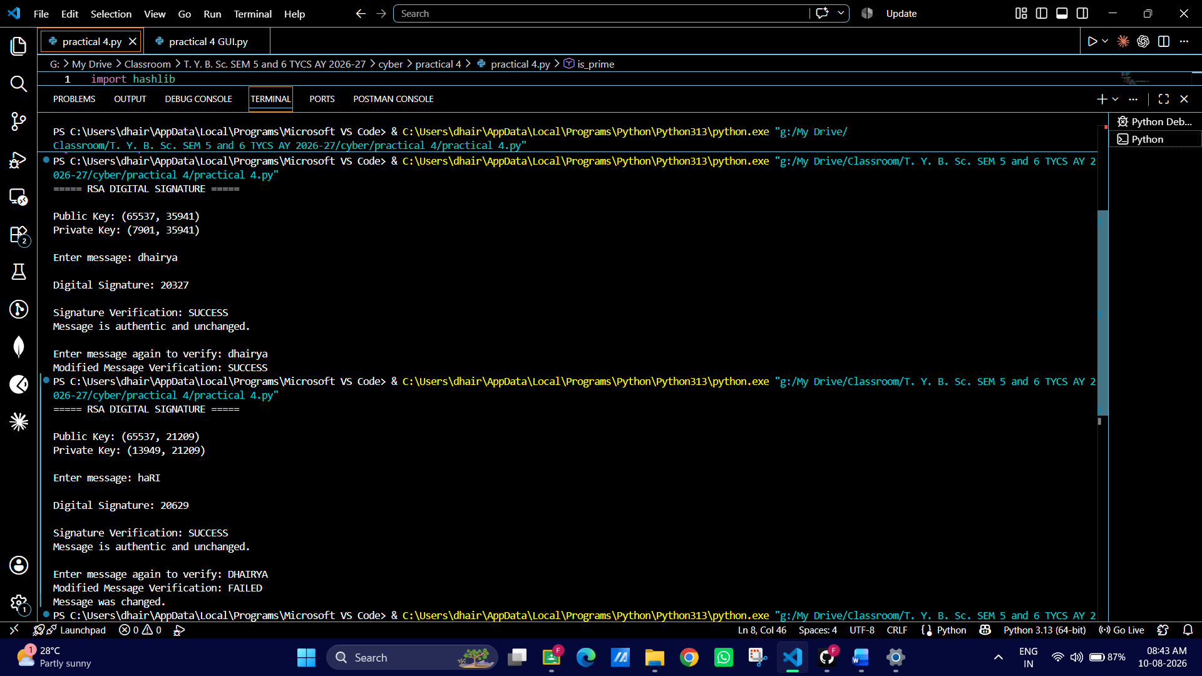

GUI
import hashlib
import random
import math
import tkinter as tk
from tkinter import messagebox

# ===== RSA FUNCTIONS =====
def is_prime(n):
if n < 2:
return False
for i in range(2, int(math.sqrt(n)) + 1):
if n % i == 0:
return False
return True

def generate_prime():
while True:
n = random.randint(1000, 5000)
if is_prime(n):
return n

def generate_keys():
p = generate_prime()
q = generate_prime()

while p == q:
q = generate_prime()

n = p * q
phi = (p - 1) * (q - 1)

e = 65537
if math.gcd(e, phi) != 1:
e = 3
while math.gcd(e, phi) != 1:
e += 2

d = pow(e, -1, phi)

return (e, n), (d, n)

def sign_message(message, private_key):
d, n = private_key
hash_value = hashlib.sha256(message.encode()).hexdigest()
hash_number = int(hash_value, 16) % n
signature = pow(hash_number, d, n)
return signature

def verify_signature(message, signature, public_key):
e, n = public_key
hash_value = hashlib.sha256(message.encode()).hexdigest()
hash_number = int(hash_value, 16) % n
recovered_hash = pow(signature, e, n)
return recovered_hash == hash_number

# ===== GUI =====
public_key, private_key = generate_keys()
signature = None

def sign():
global signature
msg = entry_msg.get()
if msg == "":
messagebox.showwarning("Error", "Enter a message")
return

signature = sign_message(msg, private_key)
text_output.delete(1.0, tk.END)
text_output.insert(tk.END, f"Public Key: {public_key}\n")
text_output.insert(tk.END, f"Private Key: {private_key}\n\n")
text_output.insert(tk.END, f"Message: {msg}\n")
text_output.insert(tk.END, f"Signature: {signature}\n")

def verify():
msg = entry_verify.get()
if signature is None:
messagebox.showwarning("Error", "Sign a message first")
return

result = verify_signature(msg, signature, public_key)

if result:
messagebox.showinfo("Verification", "✅ SUCCESS\nMessage is authentic")
else:
messagebox.showerror("Verification", "❌ FAILED\nMessage modified")

root = tk.Tk()
root.title("RSA Digital Signature")
root.geometry("500x400")

tk.Label(root, text="Enter Message:").pack()
entry_msg = tk.Entry(root, width=50)
entry_msg.pack()

tk.Button(root, text="Sign Message", command=sign).pack(pady=10)

tk.Label(root, text="Verify Message:").pack()
entry_verify = tk.Entry(root, width=50)
entry_verify.pack()

tk.Button(root, text="Verify Signature", command=verify).pack(pady=10)

text_output = tk.Text(root, height=10, width=60)
text_output.pack(pady=10)

root.mainloop()

Output:
